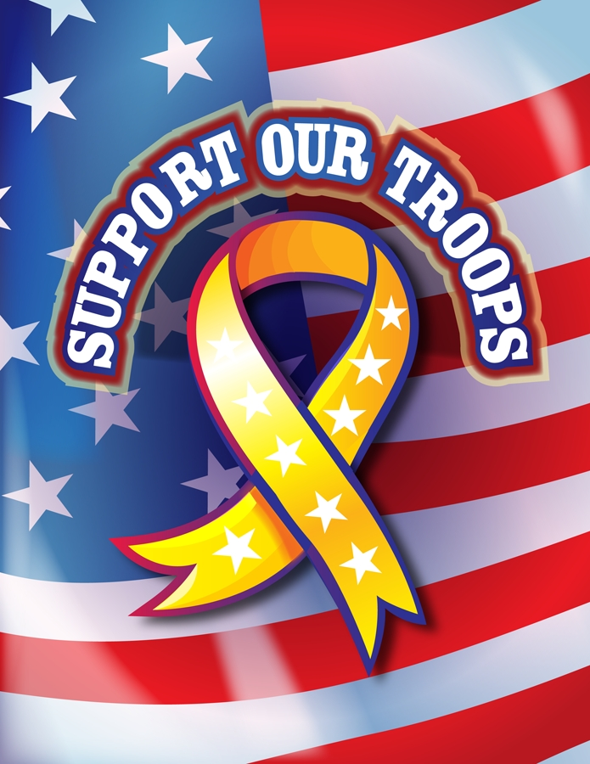
VETERANS’ DAY, NOVEMBER 11TH
Extra credit Poetry Assignment

In Flanders Fields
By: Lieutenant Colonel John McCrae, MD (1872-1918)
Canadian Army
IN FLANDERS FIELDS the poppies blow
Between the crosses row on row,
That mark our place; and in the sky
The larks, still bravely singing, fly
Scarce heard amid the guns below.
Veterans’ Day has been a federal holiday in the United States since 1938; originally called Armistice Day, it commemorated the end of World War I on November 11, 1918. After World War II, the name was changed to Veterans Day. Congress declared it a day to honor all veterans in 1954.

We are the Dead. Short days ago
We lived, felt dawn, saw sunset glow,
Loved and were loved, and now we lie
In Flanders fields.
Take up our quarrel with the foe:
To you from failing hands we throw
The torch; be yours to hold it high.
If ye break faith with us who die
We shall not sleep, though poppies grow
In Flanders fields.
This poem was written to commemorate the soldiers who died in battle.

There are many ways that people can honor those who have fought for our country, including family members who have given so much of their lives so that you may enjoy the freedoms of the life you lead.
Your assignment is to:
- Choose one of the suggestions below
- Write a poem based on your selection

Suggestions:
- Interview a family member who is a Veteran-find out where he or she was stationed, what specific battles he or she saw, the names and descriptions of people whom he or she fought alongside. Write a poem using the format on the back.
OR
- Write a free-verse poem based upon what you learn from your interview.
- Research Veteran’s Day from internet resources. Some sites that you may want to visit are:

- http://www1.va.gov/vetsday/

- http://www.patriotism.org/veterans_day/

- http://www.holidayinsights.com/other/veteran.htm

One format that you may consider using for your interview poem is as follows:

LINE 1: I am _________________________________ (your name goes here)

Line 2: _________________________________ of ________________________
(your relationship to the veteran you interviewed) (name of the veteran)

line 3: Who fought in _________________________________(write the name of the war he/she fought in)
line 4: alongside _________________________________ (write the names of people he/she was in battle with)
line 5: and felt ___________________________________ (write three adjectives to describe how he/she felt during their time of service)
line 6: Who remembers laughing when _________________________________ (write one event that made the veteran laugh)
line 7: and remembers crying when ____________________________________ (write one memory that made him/her sad)
line 8: and can still hear the sounds of __________________________________ (what sounds does he/she remember while they were overseas?)

line 9: who hopes that _________________________________________.( what would your relative like us to learn form him/her?)
line 10: I am proud of my _________________________________(your relationship to the veteran)

line 11: Please remember (his/her) service to our great nation.

Example:

I am Jimmy Johnson
Grandson of Sergeant Thomas J. Johnson
Who fought in Korea
Alongside his friends Billy Sherwood and Walter “shortstuff” Kelly
And felt scared, tired and homesick
Who remembers laughing when a skunk crawled into his foxhole
And remembers crying when his best friend was killed
And can still hear the sounds of crickets and mortar fire
Who hopes that we realize the sacrifices that our veterans made.
I am proud of my grandfather.
Please remember his service to our great nation.

Your assignment is due on: ___________________________________________________

This is an extra credit assignment. It is worth ____________________________________

Please know that you may be asked to read this poem during our annual Veterans’ Day Ceremony.
You should be proud to be honored in this way!

