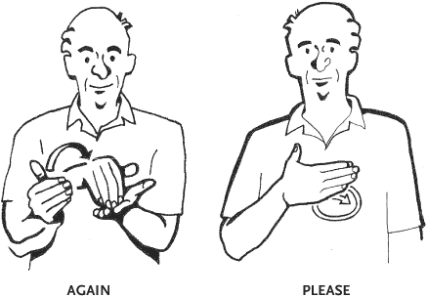

When you notice a word, phrase, or situation mentioned over and over,

Stop!

And ask yourself:

“Why does this keep happening again and again?”



Aha!

**Aha Moment!** When a character realizes, understands, or finally figures out something,

Stop!

And ask yourself:

“How might this change things?”

Contrasts

And *Contradictions*

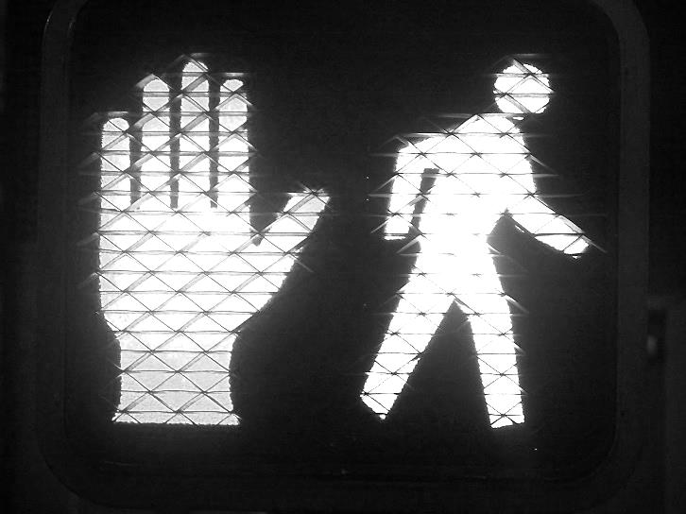

When a character does something, that contrasts with what you’d expect, or contradicts his earlier acts or statements,

Stop!

And ask yourself:

“Why is the character doing that?”

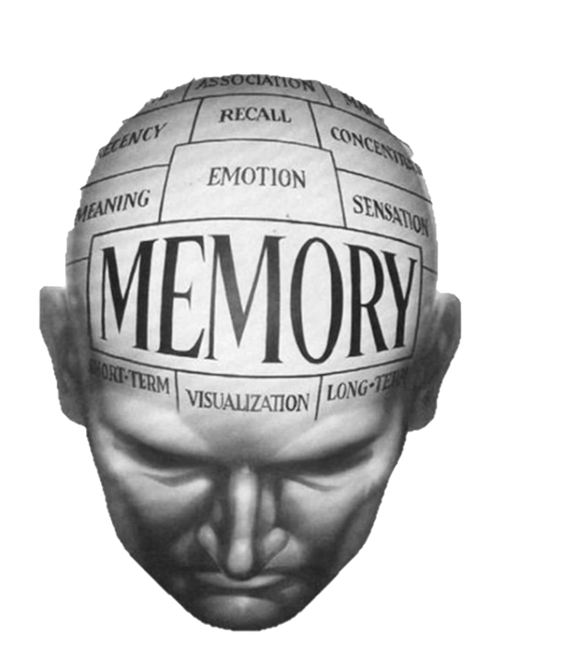

**Memory**

**Moment**

When the author interrupts the action to tell you about a memory,

Stop!

And ask yourself:

“Why might this memory be important?”

Tough

Questions

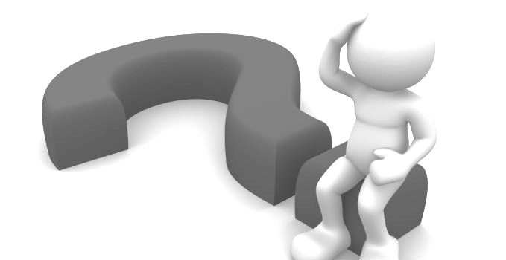

When a character asks herself a very difficult question,

Stop!

And ask:

“What does this question make me wonder about?”

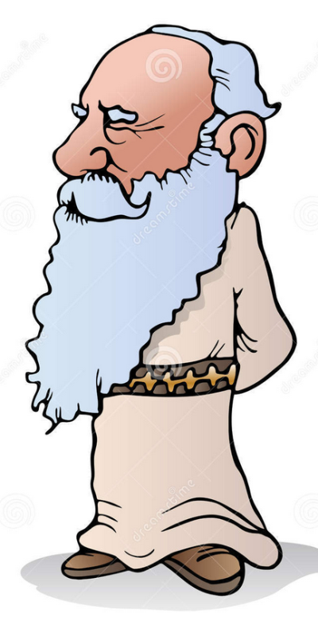

Words of the Wiser!

When a character

(probably older and wiser)

takes the main character aside and offers serious advice.

Stop!

And ask:

What’s the life lesson, and how might it affect the character?

(The life lesson may just be the THEME of the story)