Directions: Your partner will watch you perform the overhead smash 5 times. If the cue is performed then check “can do”; if not check “needs practice”. Your performance need to be to the best of your ability using appropriate technique.
FORCE | Instructional Cue | Image |  | Attempt #
 | Starting position: Non racket side to target | 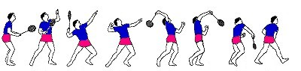 |  | #1 | #2 | #3 | #4 | #5
 |  |  | Can Do
 |  |  | Needs Practice
 | Scratch your back. Contact made with a straight elbow . |  | Can Do
 |  |  | Needs Practice
MOMENTUM | Body weight is shifted from the rear (back leg), then forward as racket comes forward. Contact made with straight elbow. | 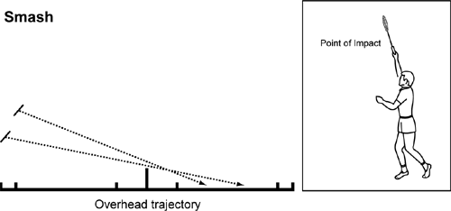 | Can Do
 |  |  | Needs Practice
 | Follow-Through: Across your body |  | Can Do
 |  |  | Needs Practice
 | Hit the Target Area |  | Can Do
 |  |  | Needs Practice
After each person has made five smashes,/drives please identify one suggestion to improve their smashing/driving technique. Please list three positive comments about your partner’s smash/drive technique.
List one suggestion to improve your partner’s overhead smash/drive technique:
#1:

List three positive comments about your partner’s overhead smash/drive technique. Please use instructional cues and science terminology:
#1:
#2:
#3:

