NAME ____________________________________________________ PERIOD_________

CHAPTER 21 REVIEW GUIDE

**WORLD WAR I**

* Propaganda: ____________________________________________________________________
* Reparations: ____________________________________________________________________
* Nationalism: ____________________________________________________________________
* Armistice: ______________________________________________________________________
* Militarism: _____________________________________________________________________
* Bureaucracy: ___________________________________________________________________

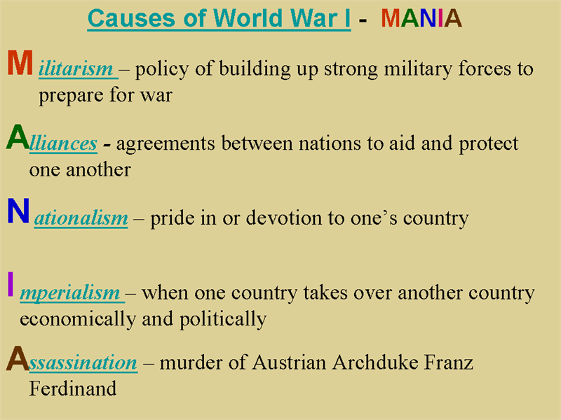

Identify the causes of **World War I**.

**M____________________________**

**A____________________________**

**N____________________________**

**I_____________________________**

**A_____________________________**

Identify the **two alliances** and their stronger members.

* _________________________
* _________________________
* _________________________
* _________________________
* _________________________
* _________________________

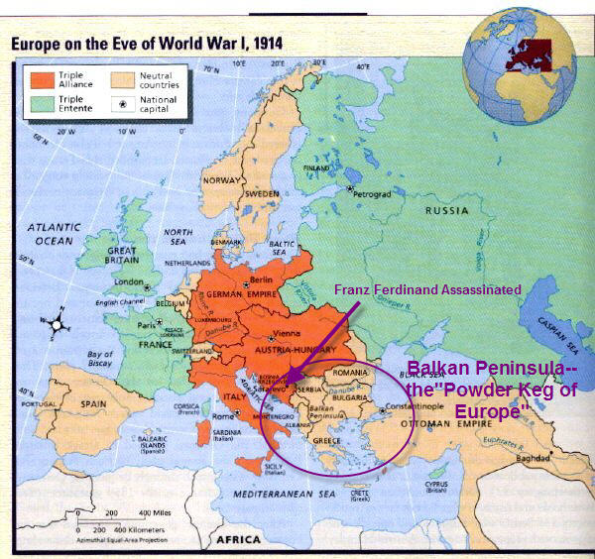

**Peace Offensive**- _______________________________________________________________________

How did *President Wilson* hope to end the war? _____________________________________________

***Zimmermann Telegram*** (note)???? _______________________________________________________

What was the goal of Wilson’s peace plan and the ***League of Nations***? ___________________________

**WIB**?? _______ ______________ ____________:

What was the purpose of this department? ___________________________________________

Identify ***trench warfare***. _____________________________________________

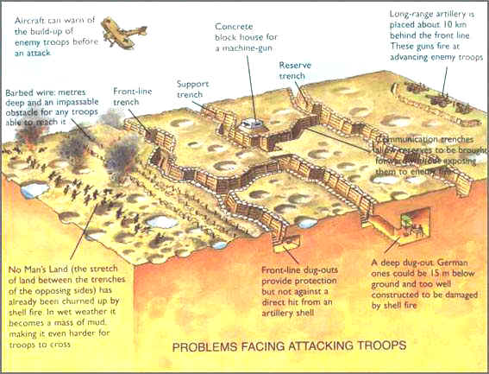

Describe military life for ***African American soldiers***. __________________________________________________________________

List the three reasons why the U.S. will eventually join the war.

1. ____________________________________________________________________
2. ____________________________________________________________________
3. ____________________________________________________________________

**Selective Service Act**: ____________________________________

DRAFT

Why did the U.S. Senate reject the ***Treaty of Versailles***? _____________________________________________________________________________________

How did the war affect the U.S. financially? ________________________

**Mobilization**: ________________________________________________________________________

What was the “**spark**” that began World War I? _____________________________________________

Identify the **Big Four**. 1. _____________ 2. ______________ 3. _______________ 4. ________________

**Pacifist**: _____________________________________________________________________________

Russia signed a peace treaty with ___________________________, ending their part in the war.

How did *women* help the war effort back on the home front? __________________________________________________________________________________________________________________________________________________________________________

**Communism**: ________________________________________________________________________

**14 Points**: ___________________________________________________________________________

**Food Administration**: _________________________________________________________________