It’s been a very short week, but we’ve been

busy in Room 9!

**Reading**

During Reading lessons, we have focused on:

- THINKING WHILE READING and finding “talking points” to share with our partners

- talking “long and strong” about a book we have read

- continuing our study of the nonfiction author Steve Jenkins while learning lots of cool facts about animals and the world!

- identifying the MAIN IDEA and DETAILS of short paragraphs

Update on Charlotte’s Web:

We’re up to chapter 14! Boy are we glad Charlotte came up with a plan to save Wilbur! We’ve continued to look for interesting new vocabulary words as we read too! We also renamed some of our yoga poses for characters from the book! Ask your child to show you the Templeton pose!

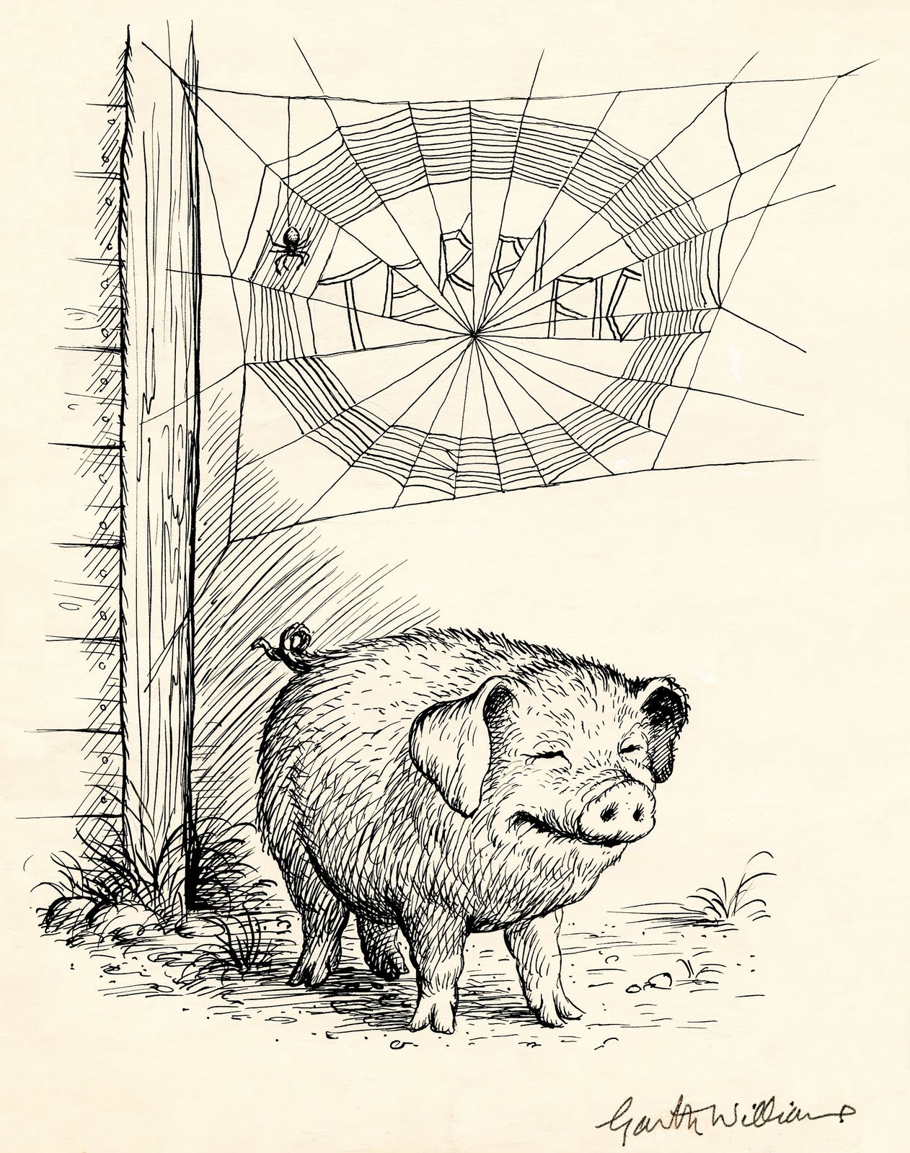

**Math**

Our Math lessons have centered on:

- continued practice with skip counting by 5s and 10s up to 1,000!

- identifying how many TOTAL TENS are in a 3-digit number

400 has 40 tens, even though it has a

0 in the tens place

689 has 68 tens, even though it has 8

in the tens place

* HINT: We can use the first 2 digits of a 3-digit number to tell us the number of tens hidden in the number!

**Announcements**

** Our field trip to the high school has been rescheduled for Monday, February 26th. New permission forms will probably come home this week so be on the lookout for them!

** We’re having a Family Movie Night on February 2nd to watch *Charlotte’s Web*! Come at 6 p.m. with your pajamas, blankets, and stuffed animals! ☺

**Science / Social Studies**

This week, we have done some work with MAP SKILLS. We’re learning to read and make maps and to identify map parts: compass rose for directions, map keys, symbols, etc. We’re learning maps are a bird’s-eye (or aerial) view of a place too. We’re learning to give and follow directions on various types of maps as well.

We had an All School Assembly on Friday and got to see three first grade classes perform a song that was part of a Martin Luther King Jr. Tribute this past week at the high school. We also learned a Zulu song about peace too!

**Writing**

In Writing, we have focused on:

- thinking about our AUDIENCE to know what kind of information we need to put in our nonfiction books to make them most interesting

- adding in nonfiction text features

- writing longer and stronger on our pages

Our spelling/phonics lessons focused on:

- patterns for long e (EE, EA) and short e

- words ending with double consonants like

-ll, -ss, -ff (spill, mess, fluff)