The body adapts to the demands of exercise by improving its functioning. When the amount of exercise (also called overload or stress) is progressively increased, fitness continues to improve. This is the principle of progressive overload.

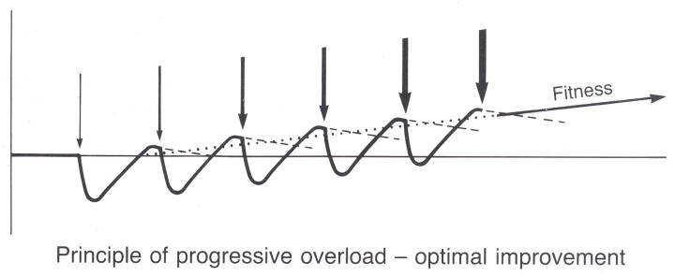The amount of overload is very important. Too little exercise will have no effect on fitness (although it may improve health); too much may cause injury and problems with the body's immune system and for my levels. The point at which exercise becomes excessive is highly individual – it occurs at a much higher level in an Olympic athlete than in a sedentary person. For every type of exercise, there is a training threshold at which fitness benefits begin to occur, a zone within which maximum fitness benefits occur, and an upper limit of safe training. The amount of exercise needed depends on the individual’s current level of fitness, his or her fitness goals, and the components being developed. A novice, for example, might experience fitness benefits from jogging a mile in 10 minutes, but this level of exercise would cause no physical adaptations in a trained distance runner.

Simply put, progressive overload is constantly challenging your muscles and heart by putting them through different workouts on a regular basis, so they don't adapt to a routine. Therefore consider the following when creating a routine:

* Regularly increasing intensity (increased heart rate), once it becomes too easy.
* Progressing intensity of cardio sessions
* Progressing time of cardio sessions. You should be working on more intense workouts in less time, and less intense sessions, with more time.
* Changing equipment type for lifting and cardiovascular activity.
* Progressive overload can also include adding more days to your workout week.

**TASK**:

Using what we know about progressive overload, apply the concept to cardiovascular fitness and create a 5 week program using the FITT principle. Remember the program should show progression.

**WEEK 1**

|  |  |
| --- | --- |
| **FREQUENCY** |  |
| **INTENSITY** |  |
| **TIME** |  |
| **TYPE** |  |

**WEEK 3**

|  |  |
| --- | --- |
| **FREQUENCY** |  |
| **INTENSITY** |  |
| **TIME** |  |
| **TYPE** |  |

**WEEK 5**

|  |  |
| --- | --- |
| **FREQUENCY** |  |
| **INTENSITY** |  |
| **TIME** |  |
| **TYPE** |  |

NAME: ____________________________________________________