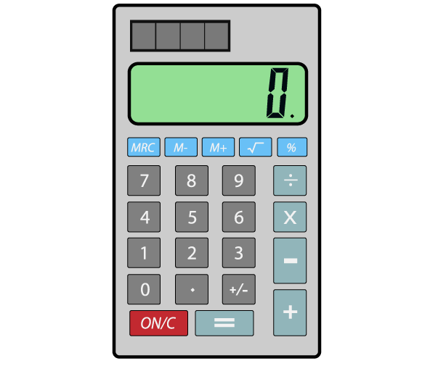Name___________________________________

|  |
| --- |
| https://lh6.googleusercontent.com/5JnXXnS_hlAPx4YykdCT5yi0rcrGnBUjQm-g86QfqDMWMJwxQ5_glV2qlriMCpCGIRy6u5D1xW9-xL6pj3fhMaMhUIyE_ISNUaQmczXvq6fompAbSuWp7KoAwH3F1DYQNYwWqqlHXa1JaZFC8w |
| 1. https://lh3.googleusercontent.com/cyLzXI2r-k-1yIBHHMe3P_nt_AVMPsTe-Rs0qsILO1MWYu84_IBasdBebltUvl2NSoad2deGQxYF9Gzuz9BoBmLnmM1DP5uoLZzNzT9jFQrpLX-msu_8gR7vKOYnNIvaEH50DipDn9pSXvuLzQ |
| 1. https://lh4.googleusercontent.com/QlbxIIU9S7HDkaKztFzJForbbdAuOrN3FwwHxm08oe5UBglXtAOswq99BDax0qXVrBQWfBtNI321qgNcDwp5iZ6GUlaGeBtIMEg-geZSZkx4cIwLAqfWazWK8VvROljftLan69894eEqT0cRjA |

**SP Cumulative Review**

|  |
| --- |
| 1. https://lh3.googleusercontent.com/l0wkj-A1vcbwWXHoCqKBWqgKVnQ8PtvJvbs_6ZzO1aPaspHqVVlq6ZIx5zGrL4m_erQC2-91db561gVsdQLWxox4ltq5NpmVW36Jm_cXCJSioV-xTD-psAHHEWfJrdUQ4zyo78oKp9lrrSGSVA |
| 1. https://lh3.googleusercontent.com/7LiTpFCj53km-ZxLavXmb81Smh18jBDG9uAahRrOSt0rUkL18CVpLMlyGbEkyYvio67mZsuUcnhDW-uAgqeipaw8NXIEA0dkc04zl-aewh49s0CmyYXVtqIw93IO3UN0IVRkhygIl1y8f-5T-Q |
| 1. https://lh5.googleusercontent.com/5w_x_PrwNihO2zTn6kRLlC9Qc_qz_M-Hhn6dYMc1qi8PXXQSMGpoMXca9Jc9s4RNiGa3hwC1glMNZEvbp_YIq4xlZTv9iOZcB6Vc3O90aFFQztiN_5tJ_MKw6OWIYVFCDDbN8qz34ZFCDwYFXg |
| 1. https://lh4.googleusercontent.com/U3Du6ztkI5G1qsd5CPeTdGh8AY6_SIZZFsTznsqoUdIeDm6MhjnxA08rx1Muqq0eNP9W6OSwgfTI7hjlBpqvVQNLMyhfs1qLu-amtISTVnjPIWZkcGmegHiHMZ15sqovHxeiC4JDokKz7JsYnA |
| 1. https://lh3.googleusercontent.com/fc2zXObanhXSh5KtMQF0QzND83LEuubMCXn6Bt-Wq3o8xruqm04Eb63-DcgD2f4aSgQq8Ji2LseFtmO3H-VlH-rkdbE64_fFdWq8PTQz_ecPhX7EovFVS6bG_d7Dp1uTrTeQXsd3wjiijrUvDA |
| 1. https://lh6.googleusercontent.com/AnYNQRuIHsbGWqLfSqG_gC34XN-p3rXCr5OevV83Lw8hV1ZzxeHg1tplf-hoUTZIZvPapBbPAv5fOBxuE_Oats020g0n6M6g3SMIrc2jLJ7-Kjn-2binTk7AZqqaVd-yNIl3bZk9vebkDwhGlg |

**Extended Response:**

1. 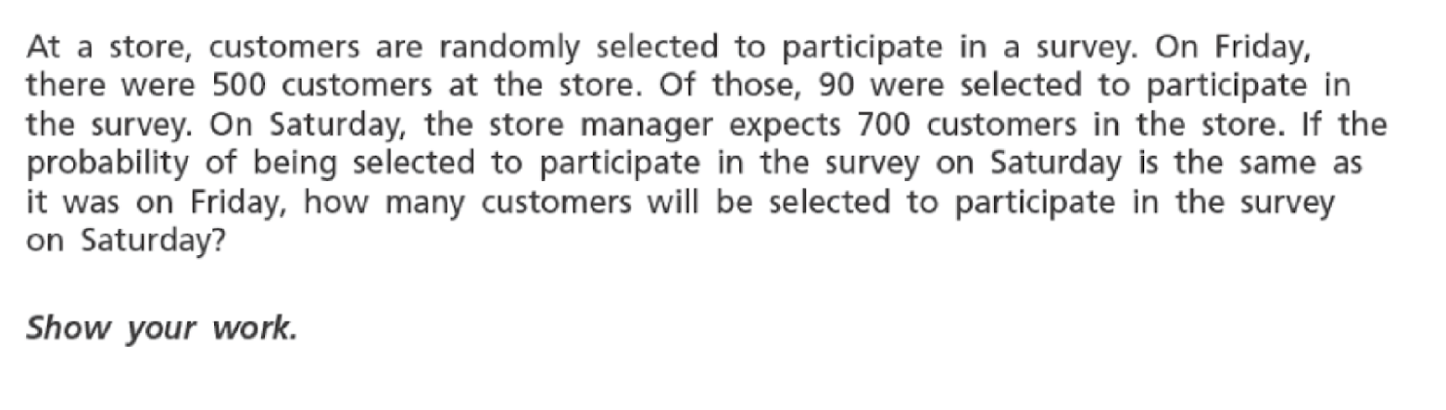
2. 