Directions: Your partner will watch you perform the overhead drop shot 5 times. If the cue is performed then check “can do”; if not check “needs practice”. Your performance need to be to the best of your ability using appropriate technique.
FORCE | Instructional Cue | Image |  | Attempt #
 | Moves feet to reach correct position for clear shot. Stand perpendicular to net. | 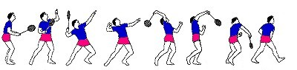 |  | #1 | #2 | #3 | #4 | #5
 |  |  | Can Do
 |  |  | Needs Practice
 | Scratch your back. Contact made in front of body with a straight elbow. |  | Can Do
 |  |  | Needs Practice
MOMENTUM | Weight is shifted to front foot as contact is made. |  | Can Do
 |  |  | Needs Practice
 | Block or tap the shuttle as you hit it, reducing the speed of the racket head. | 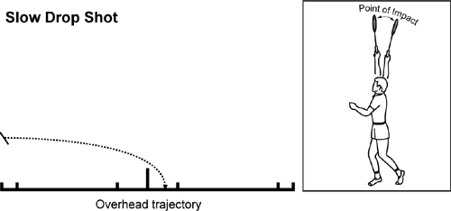 | Can Do
 |  |  | Needs Practice
 | Follow through across the body. Birdie lands in the first 1/3 of court. | 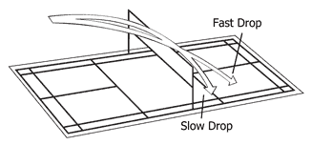 | Can Do
 |  |  | Needs Practice
After each person has made five drop shots, please identify one suggestion to improve their technique. Please list three positive comments about your partner’s serving technique.
List one suggestion to improve your partner’s overhead drop shot technique:

#1:

List three positive comments about your partner’s overhead drop shot technique. Please use instructional cues and science terminology:
#1:
#2:
#3:

