Name __________________

Date ___________________

Class ___________________

Procedure:

1). Cut the paper in half along the fault line

2) Place the 2 halves of the paper together so they match up

3) Slide Side “B” up along the fault line about 3 inch

4) Diagram what your model looks like in Box 1

5) Answers the questions in section 1

6) Place the 2 halves of the paper together again so they line up

7) Slide side “B” down along the fault line about 3 inches

8) Diagram what your model looks like in box 2

9) Answer the questions in section 2

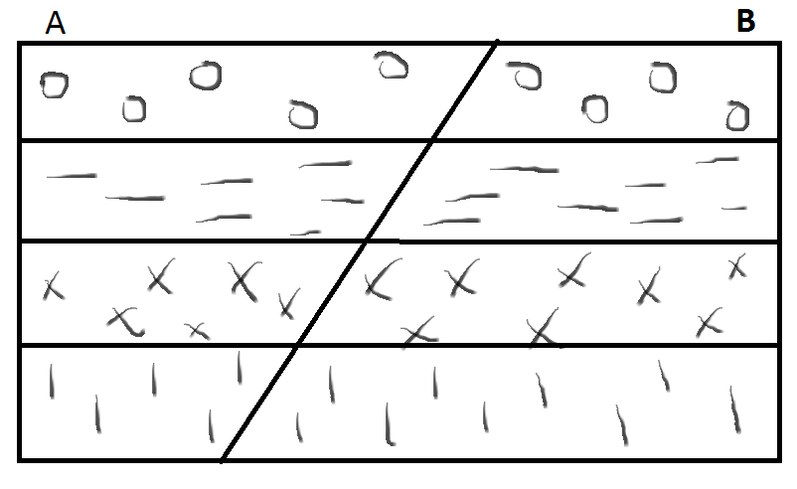

Diagram your Faults

|  |  |
| --- | --- |
| 1). | Section 1  1). Draw arrows showing relative movement.  2) Draw arrows showing the stress involved.  3) Identify the hanging wall.  4) Identify the footwall  5) Is this a vertical or horizontal fault?  6) What type of fault is this?  7) What happened to the length of crust in the area?  8) What do you call the boundary where the movement happened? |
| 2). | Section 2  1). Draw arrows showing relative movement.  2) Draw arrows showing the stress involved.  3) Identify the hanging wall.  4) Identify the footwall  5) Is this a vertical or horizontal fault?  6) What type of fault is this?  7) What happened to the length of crust in the area? |

Conclusion questions

1). Explain the 3 types of stress that change rocks?

A)________________________________________________________________________________________________________________________________________________________________________B)________________________________________________________________________________________________________________________________________________________________________C)________________________________________________________________________________________________________________________________________________________________________

2) What is folding of a rock? __________________________________________________________________________________________________________________________________________________________________________

3) Explain the 2 types of folds?

A)________________________________________________________________________________________________________________________________________________________________________B)________________________________________________________________________________________________________________________________________________________________________

4) What is Faulting? _________________________________________________________________________________________________________________________________________________________________________

5) Explain the 2 halves of a fault (what is on each side of the fault)?

A)________________________________________________________________________________________________________________________________________________________________________B)________________________________________________________________________________________________________________________________________________________________________

6) What 3 things affects whether a rock will fold or fault? _____________________________________________________________________________________7) Diagram and explain the 5 types of faults:

|  |  |  |  |  |
| --- | --- | --- | --- | --- |
| 1) | 2) | 3) | 4) | 5) |