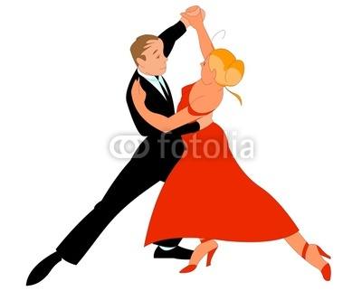

**6th Grade Band**

**Winter Concert Information**

Dear 6th Grade Band Students and Parents,

The winter concerts for Union Vale Middle School are about one month away! We have been working very hard and are looking forward to our performance. Below you will find all of the information you need about the upcoming concert season.

**Concert Information**

**Date:**  Tuesday, December 8th

**Student Arrival Time:** 5:55pm

**Concert Start Time:** 7:00 pm

***Mandatory Afterschool Dress Rehearsal:*** *Monday, November 23rd (2:20-3:20)*

**Concert Dress :** Black Dress Pants (no jeans, jeggings, or leggings) or Black Skirt (must be knee length or longer to perform), Black Shoes (no flip flops), Black Socks, Black Shirt (polo/button down), or Blouse (with no writing or spaghetti straps), NO TIE

**Concert dress is required for all band performances and will be strictly enforced. Please call or email me as soon as possible if you anticipate having trouble obtaining these items, I know how quickly the students grow out of clothing.

The Union Vale Middle School concert dates and groups are listed on the back of this letter. Concert attendance is mandatory. If you have a conflict please let me know as soon as possible. Excused reasons for an absence would include a family emergency, special ceremony, or legal illness. As always, thank you for supporting the Arlington Music Program, we look forward to seeing you in December.

Attached to this letter is our annual poinsettia music fundraiser. All proceeds your child earns will go to the music department to purchase new music, instruments, and equipment. The poinsettias are ordered through *Adam’s Fairacre Farms* and are always beautiful. If you, family members, or friends purchase poinsettias for the holiday season please consider ordering them through the music department this year.

Sincerely,

Ms. Gaspary

**Concert Etiquette**

**All performers and audience members are asked to stay for the entire concert**

We pride ourselves on running our concerts smoothly and in the most time efficient manner. In addition to teaching your child music and performance etiquette, we are also creating excellent audiences for the future. Please help us do this by staying for the duration (approximately 1 hour) of the concert. If you have a unique situation, which requires you to take your student home after their portion of the concert, please send a note regarding this dismissal along with the participation slip included in this letter.

**Tuesday, December 1st**

***Jazz II - 7th Band - 8th Orchestra - 8th Chorus***

**Wednesday, December 2nd**

***Fiddle Club - 7th Orchestra - 8th Band – Jazz Band***

**Thursday, December 3rd**

***Chamber Orchestra - 6th Orchestra - 6th Chorus***

**Tuesday, December 8th**

***7th Chorus – 6th Band***

**Please return this participation slip by**

***Friday, November 6th***

**If you have any questions please feel free to email me at** [**ggaspary@acsdny.org**](mailto:ggaspary@acsdny.org)

My child ___________________________________ and I have written the concert date on the calendar and have read the information above. We are aware that concert attendance is mandatory and if a conflict arises a written note must be provided as to why the student will be unable to attend the concert. I understand the request for proper attire and the importance of dressing appropriately for a concert performance and will provide transportation to and from the concert for my child.

In order to teach the students about proper concert etiquette, it is expected that everyone will stay for the entirety of the concert. If a student needs to be excused after their performance, a written note is required before the night of the concert.

Parent/Guardian Signature _________________________________Date __________

Student Signature ________________________________________Date __________