NAME __________________________________________ PERIOD_____

CHAPTER 22 REVIEW GUIDE

**THE ROARING TWENTIES----------------------------THE JAZZ AGE**

* Identify the *Roaring Twenties*. ____________________________________________________________________________________________________________________________________________________________
  + - Why was it known as the *Roaring Twenties*? *This was a period in time when widespread social and political change occurred.*
* Why did farmers struggle during the 1920s?

OVERPRODUCTION!!!!!!!

Farmers produced too much. The demand wasn’t there anymore. Too much competition caused falling prices.

* Identify the **Harlem Renaissance**.

[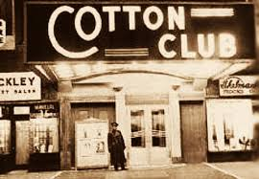](http://www.google.com/url?sa=i&source=images&cd=&cad=rja&docid=m5EdS8VGzlSMyM&tbnid=7yIJ463ydWg_WM:&ved=0CAgQjRw4Ug&url=http://utaseptember2010theharlemrenaissance.blogspot.com/&ei=uhMOU8WNF-uzsASa2oGoBw&psig=AFQjCNE2bq4lXMYEwEPT91kFitF9Su_nSA&ust=1393517882436516)

This was a period of great achievement by African American writers, artists, and performers

* + - Why is ***Langston Hughes*** a significant person in American history? __________________________________________________________________________________________________________________________________
* A **Nativist** is an American-born person that dislikes foreigners.  **Nativist’s** see no good in these in people. They believe they threaten the American way of life. They connect disease, filth, crime, and anarchy to these alien people.

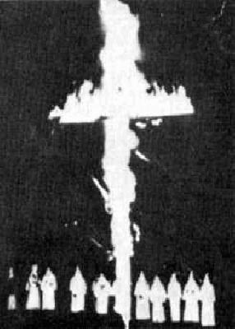

* + Why was there a resurgence of the **Ku Klux Klan** during the 1920s? ________________________________________________________________________________________________________________________________________________
  + Identify the *National Origins Act: ________________________________________________________________________________________________________________________________________________*
* Identify the ***Scopes Trial***.------------------------------------------AKA “**THE MONKEY TRIAL**” __________________________________________________________________________________________________________________________________________________________________________________________________________________
  + What type of conflict does this reflect? *Science versus religion*
* 18th Amendment: ______________________________________________________
  + ***Prohibition***: _________________________________________________________
  + ***Bootleggers***: _________________________________________________________
  + ***Speakeasies***: ________________________________________________________
* 19th Amendment: ____________________________________________________________________________________________________________________________________________________

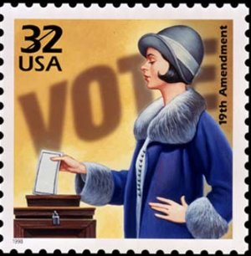

* Identify **flappers**. __________________________________________________________________________________________________________________________________________________________________________________________________________________________________________
* What caused the stock market to crash in 1929? ____________________________________________________________________________________________________________________________________________________________
* Identify the **Red Scare**._______________________________________________________
  + What was a major cause of the Red Scare in America during the 1920s? _______________________________________________________________________
* Identify the ***Great Migration. ____________________________________________________________________________________________________________________________________________________________***
  + Why did this occur? _____________________________________________________
* During what decade did the *Teapot Dome Scandal*, the *Harlem Renaissance*, and the *Scopes trial* take place? ____________________________________________________________________________________________________________________________________________________________
* What measures were taken during the 1920s to limit immigration? ____________________________________________________________________________________________________________________________________________________________