World Religions –Islam

***Directions: Use the*** [***http://www.bbc.co.uk/religion/religions/Islam***](http://www.bbc.co.uk/religion/religions/Islam) ***to complete the assignment.***

**At a Glance**

**What does Islam mean? _Submission to the will of God.**

**Islam is the 2nd largest religion in the world.**

**Muslim is the name of the followers of Islam.**

**Is Islam monotheistic or polytheistic? Circle one.**

**Allah is the name of the Muslim God.**

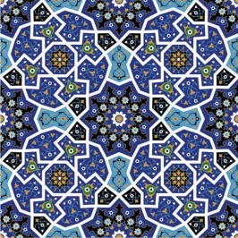**True or false. Muslims believe in Jesus, Moses and Abraham.**

**Quran is the Muslim holy book.**

**Arts and Architecture**

**True or False. People appear in Muslim religious art?**

**Why are geometric shapes important to Islamic art?**

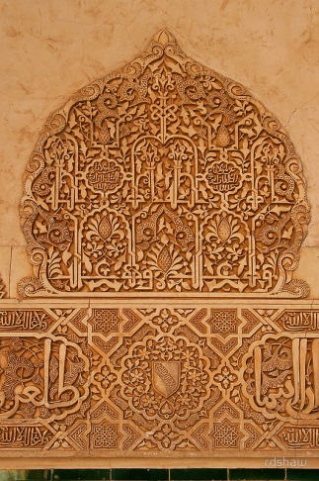**No pictures are allowed.**

**Show the continuity of the belief in Mohammed.**

**Beliefs**

**Who is the final prophet? Mohammed**

**What is a hijab?**

**Muslim headscarf worn by women**

**Shows devoutness**

**A type of veiling for woman**

**When does a woman wear a hijab?**

**When she is in the company of someone she could marry. ( so not in front of her father, brothers)**

**History**

**When was Muhammad born? 570**

**Where was he born? Mecca**

**What happened in 622?**

**Mohammed flees from Mecca and goes to Medina because his message of monotheism is not popular in Mecca. Called Hijra**

**Why is it an important year in the Islamic faith?**

**It becomes the first year of the Muslim calendar.**

When does Muhammad return to Mecca?  **630**

When does he die? **632**

What is Ramadan?

**The month that Mohammed first spoke to the Angel Gabriel**

What are two specific practices of Ramadan?

* **Fasting from sunup to sundown for one month**
* **Try to give up bad habits. (no smoking)**
* **Pray more**

**Ethics**

Select **two** ethics and provide the Muslim position on the issue.

**Practices**

What are the Five Pillars of Islam? (No need to write the Arabic term, just the description)

1. **Declaration of faith. There is one god, Allah and Mohammed is the prophet.**
2. **Pray five times a day**
3. **Give charity to the poor.**
4. **Fast of Ramadan**
5. **Make a hajj or pilgrimage to Mecca**

**Prayer and Worship**

What is a mosque?

**Muslim place of worship**

What are two actions are taken before a person enters the mosque?

**Cleansing ritual (washing)**

**Removal of shoes**

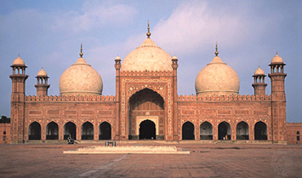What are two things not found in a mosque?

**No furniture**

**No pictures or statues**

Define: minaret

**Prayer towers. (Usually four)**

When is a minaret used?

**Used to call Muslims to prayer.**

When women go to the mosque where do they sit?

**In a separate location from the men**

What is wudu?

**Cleanliness before prayer mental preparation**

(view the pictures provided)

**Texts**

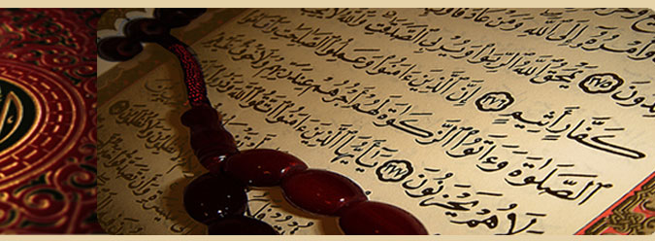What is the holy book of Islam? **Quran**

How many different translations are there of the Quran? **40**

How do Muslims show respect for the Quran?

**While the Qur'an is read aloud, Muslims should not speak, eat or drink.**

**ADD:**

**People of the Book— Christians and Jews**

**Free to worship as they please but had to pay a “nonbeliever tax”**

What is the difference between Sunni and Shi’a Muslims? To be completed in class)

**The majority of Muslims are Sunni Muslims**

**Most Shia Muslims live in Iran, Iraq and Lebannon**

**When Muhammad died there was no successor. Some believed the only leader (capilph) should be a relative of Muhammad (shia)**

**Others believed it should be a devout Muslim (Sunni)**